**I. Design History**

Formerly known as Flowers of War. While the design of the document was not very pleasing towards the audience, a full revamp of the game was made. Dawnbreakers is the game that followed. Following improvements in story elements and gameplay options. Unlike Flowers of War, Dawnbreakers now has a working digital prototype that showcases the core stealth mechanics.

**II. Vision Statement**

**Game Logline**

After a super weapon was stolen from military escort, Virtus and Kiari special agents sent to destroy the weapon before the terrorist can unleash chaos upon the world.

**Gameplay Synopsis**

Genre of the game is a Stealth action game. The goal of the game is to accomplish your objectives without being seen or killed. The game will only be a single player game where the player can choose to play as either Virtus or Kiari.

The game is set in a desert base not in the main road that’s occupied by the terrorist faction. It has warehouses and trucks that are typically seen on military bases. Enemy patrols are color coded as it determines their rank within the terrorist organization. This in turn will also determine their gameplay design.

Standard stealth mechanics such as dodge roll and wall hiding are involved. Enemies will chase you down if you are seen and will attempt to kill you. Ammunition and other pickups will exist in the game as part of the game’s level designs. Players will have the option to engage the enemy in the way they want to.

**III. Target Audience**

**Demographics**

The age demographic of the game would be teenagers (ages 16 and above), due to the game’s mature content.

**Psychographics**

Caters to players who are Explorers, Killers, and Achievers.

**Platform or Target Hardware**

The game will only be released on a single platform which is Microsoft Windows. Microsoft Windows is popular with most of the game genres including stealth-action games

**Unique Selling Points / Competition**

* + Thrilling boss battles that can be done in two separate ways between two different scenarios.
  + Play as either Virtus (Male) or Kiari (Female) in this stealth action video game.
  + Experience an era where the war economy is based on the conflict of three (3) countries.

**IV. Gameplay**

**Description or Overview**

Upon starting the game, the player is greeted with a menu screen with the title *Dawnbreaker.* Beneath are the texts *Start* and *Exit*. When they press start, a character selection screen will appear. Once the player has chosen their character, the game will start. Exit would quit the application.

**Controls**

|  |  |
| --- | --- |
| A | Interact |
| X | Melee |
| Y | Gun |
| B | Dodge |
| L1 | Toggle FOV |
| R3 | Toggle Map |
| L1 + B | Jump |

**Procedures**

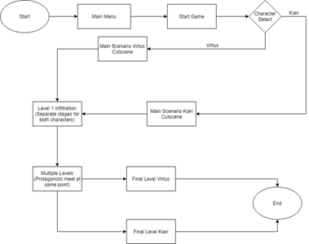

**Rules**

3 kinds of enemy patrols. Stationary, Roaming, and Static patrol. Players must avoid contact or eliminate enemies if they please.

Players have limited ammunition that they can take to the mission. Ammunition can be acquired throughout the game to replenish what they have.

Players are given a health bar that depletes if they are harmed by the enemy.

Player health is regenerated if players are out of combat for a short period of time.

Enemies will chase you under Alert phase and will return to their patrols on Clear phase.

**Scoring / Winning conditions**

Winning condition per level is the objectives of the game. Other factors are a scoring system that will determine how well the player performed on the level. This will give players a sense of mastery of how well they know the game.

**Interfaces**

The following are take from the game’s early 3D prototype and may not represent the final look of the game

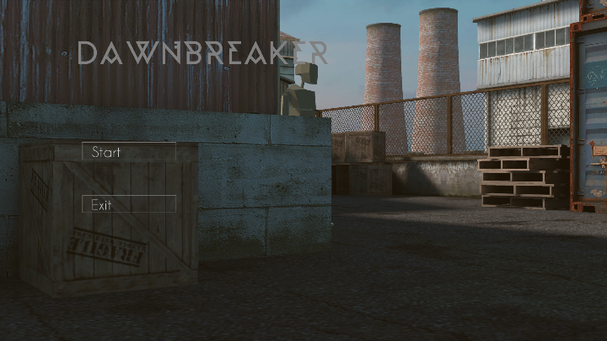

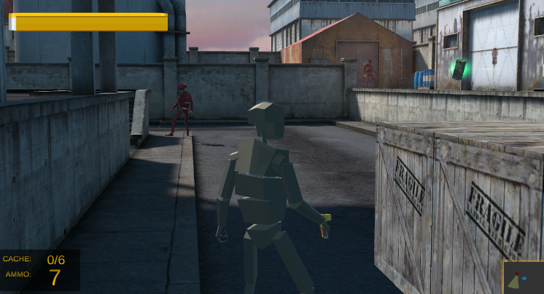

*Figure 1a: Menu Screen*   *Figure 1b: Game Screen*

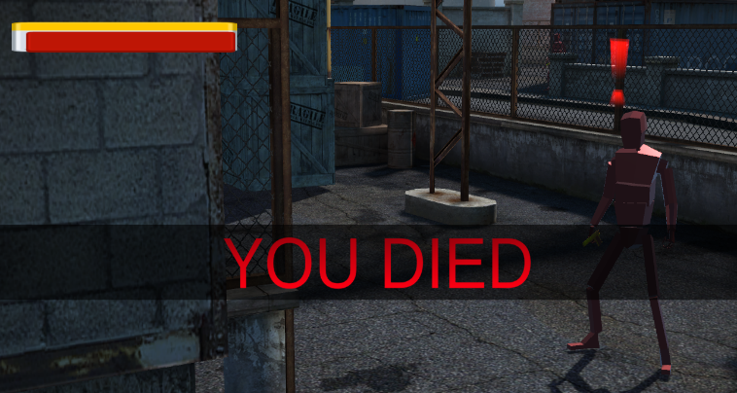

*Figure 1c: Game over Screen*

**V. Game Characters**

**Character Designs**

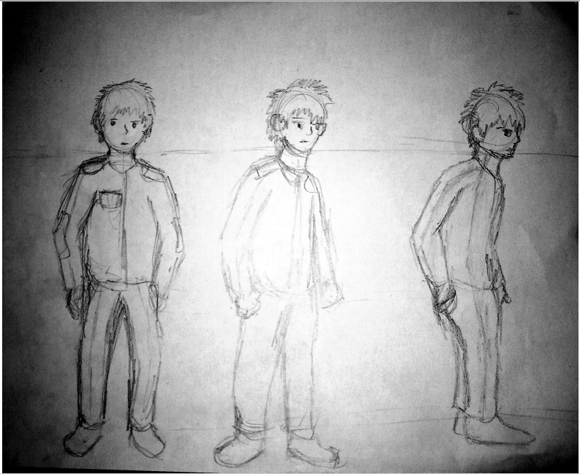

*Figure 2a: Character turn around*

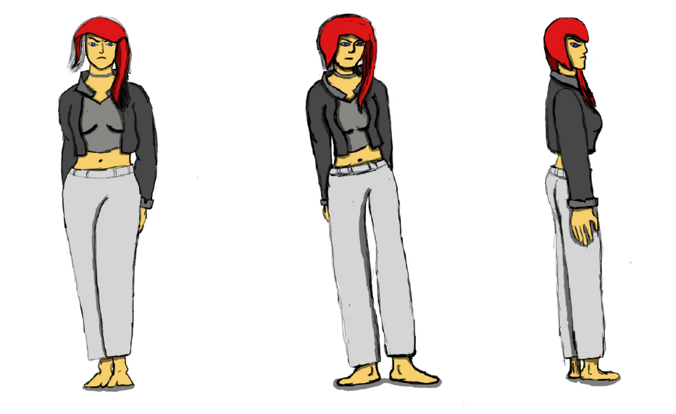

*Figure 2b: Character turn around*

**Other Resources**

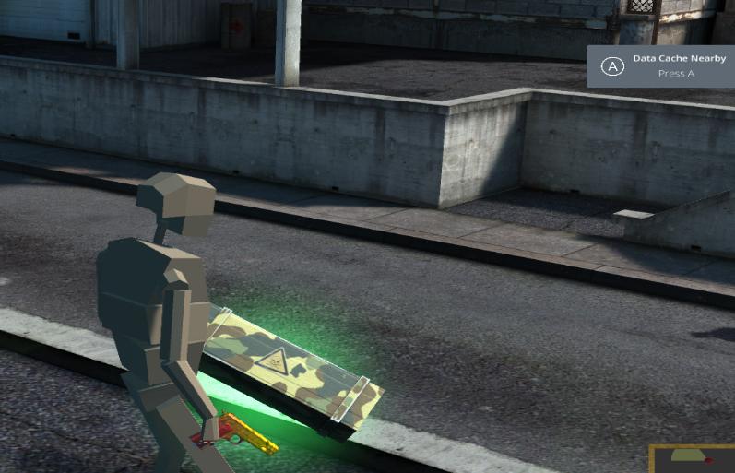

*Figure 2c: Gun and chest*

**VI. Game Story**

**Synopsis**

Terrorist organization threatens the government with a demand that will make them known. So the terrorist decide to steal the government’s top secret weapon which happens to be escorted to a secure location. They use this weapon as a bargain chip for their demands.

**Story Outline**

Virtus is a retired agent who returns to duty for a high-level classified mission. He brings along his former squadron. During the escort mission, they were ambushed by the terrorist. Upon recovery, Virtus is given a mission of redemption and vengeance. Another agent, Kiari, is also aware of the situation and is sent by a different order and later joins Virtus in his mission. They both have the same mission to stop the terrorist as well as destroy the superweapon, Dawnbreaker.

**Dramatic Arc**

The terrorist leader is a preacher who preaches the treacherous treatment the government treats them. The leader gathers followers to send a message to be known and this message ultimately leads up to a threat. Virus and Kiari eventually meet this leader in their mission and encounters him in a stealth mission.

**VII. Game World**

**Brief Overview**

The game world is set in an abandoned military base in the middle of an undisclosed location.

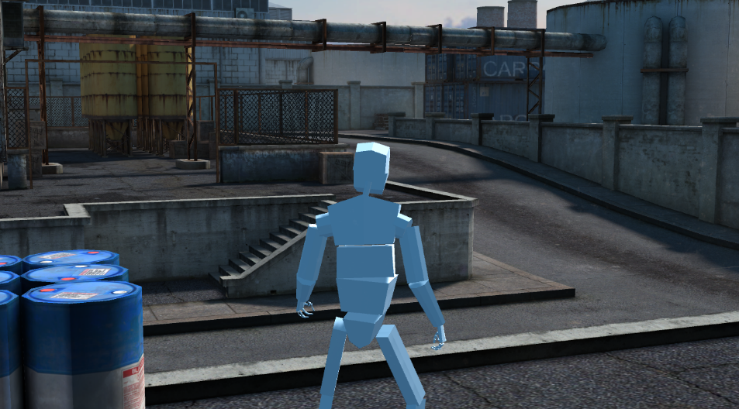

*Figure 3a: Abandoned base*

**Mapping**

The game is confined to only one level and the camera is controlled by the player.

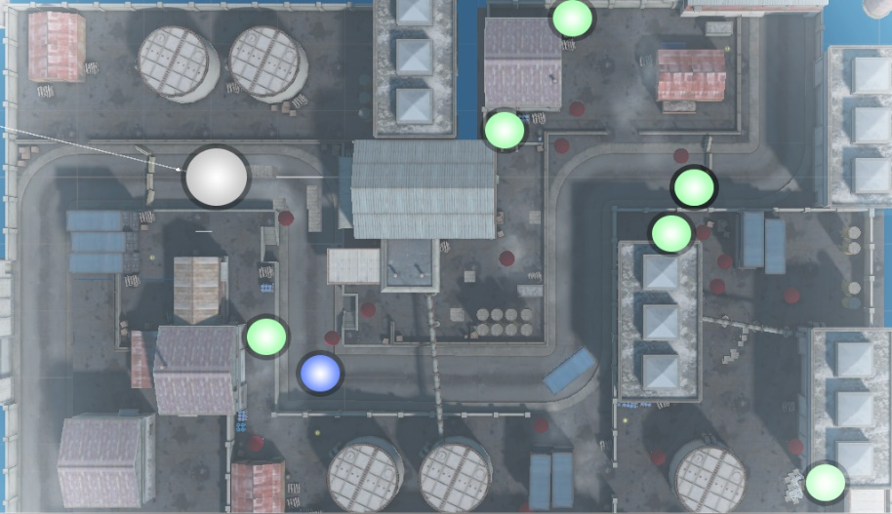

*Figure 3b: Map Overview*

**Key Locations**

Key locations are the points of interest seen on the map.

**Society/Cultural constructs**

Every member of the terrorist organization is convinced that they are treated poorly by the government. Hence, the terrorist demands the government ransom or else

they’ll unleash the weapon they stole.

**VIII. Media List for:**

**Software/Programs used**

Autodesk maya

Unity3d  
photoshop  
Visual studio 2015

**Characters**

Virtus is a retired agent who decided to return to duty after hearing of a classified mission. His treats his squadron as his family and considers them as brothers in arms. After the loss of his comrades, the thought of vengeance has been the only force driving him to stay alive and complete the mission.

Kiari is another agent sent by another organization in response to the terrorist threat. She has no sympathy or remorse for the terrorist as she is trained to kill without a 2nd thought. She completely understands Virtus’ quest for vengeance as she has experience with loss as well.

**Glossary of Terms**

***Dawnbreaker*** – A superweapon secretly developed by the government that needed to be relocated to a secure location. It’s a weapon that can devastate an entire city.